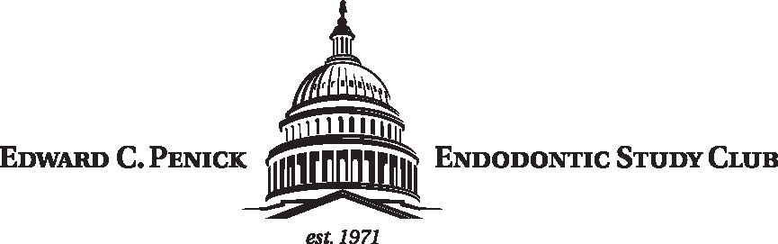

DUES SUBMISSION INFORMATION 2022-2023

MEMBERSHIP FEE SCHEDULE AND STATUS

REGULAR MEMBERS - $300.00

STUDENT - $175.00

Dues must be paid electronically via Zelle or via mail prior to the first meeting. Dues cover the cost of all CE and include meals and non-alcoholic beverages for in-person meetings (a cash bar will be available).

Dues Payment
Please be sure to include your first and last name as well as e-mail address with all forms of payment to be added to the active member roster.

Preferred:
ZELLE Account:
202-255-5056
Drm@dcendodontics.com

OR

Personal Check:

Send your first and last name and e-mail address along with a check payable to:
EDWARD C. PENICK ENDODONTIC STUDY CLUB

TO:

Dr. Julian Moiseiwitsch
5225 Wisconsin Ave NW
Suite #303
Washington, DC 20015

