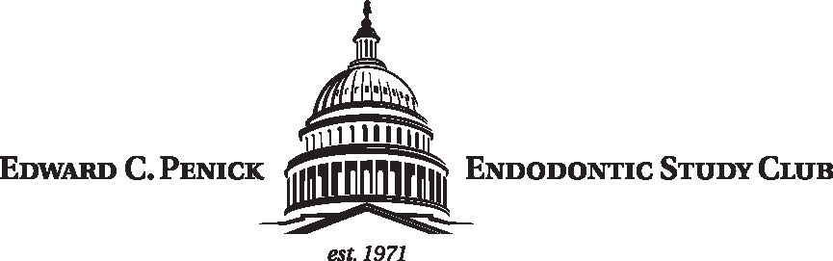

MEMBERSHIP FORM 2020-2021

NAME _____________________________________________

ADDRESS _____________________________________________
_____________________________________________

_____________________________________________

TELEPHONE _____________________________________________

E-MAIL ADDRESS _____________________________________________

MEMBERSHIP STATUS (check one)

ACTIVE - $200.00

STUDENT - $200.00

INACTIVE - $10.00

RETIRED - $10.00
(Individual approval by executive council required)

AMOUNT ENCLOSED $ _____________________

Checks should be made payable to:
EDWARD C. PENICK ENDODONTIC STUDY CLUB.

RETURN FORM WITH CHECK TO: OR EMAIL FORM WITH ELECTRONIC PAYMENT TO:
Dr. Julian Moiseiwitsch
5225 Wisconsin Ave NW
Suite #303
Washington DC 20015

Email Form: secretary@penickstudyclub.com

ZELLE Account:
202-255-5056
Drm@dcendodontics.com

